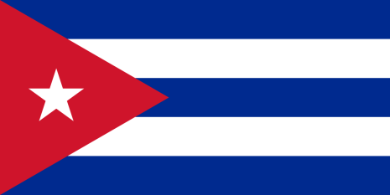
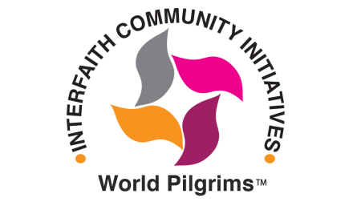

Information Required for Religious Visa to Cuba
Traveler name – as it appears on your passport
Gender
Mother’s Maiden Name
Date of Birth (mo/day/year)
Place of Birth
Telephone
Email
Home Address
Citizenship
Passport No.
Passport Issued: City and Date
Date of Passport Expiration
Congregation
Visited Cuba Before?
Were you born in Cuba?

Please complete this form and return it by email to
Worldpilgrims.ici@gmail.com
Or by mail to
ICI/World Pilgrims
669 East Side Ave, SE
Atlanta, GA 30316

For more information, contact Jan Swanson at 404-906-7109

